1. Section III – Story, Setting and Character TK
   1. Story and Narrative - Specific details like scripts and cut scenes may not be in this document but be in the Story Bible.
      1. Back story
      2. Plot Elements
      3. Game Progression
      4. License Considerations
      5. Cut Scenes
         1. Cut scene #1
            1. Actors
            2. Description
            3. Storyboard ASSIST : BRUNO
            4. Script
         2. Cut scene #2
         3. etc.
   2. Game World
      1. General look and feel of world
      2. Area #1
         1. General Description
         2. Physical Characteristics
         3. Levels that use area
         4. Connections to other areas
      3. Area #2
         1. etc.
   3. Characters
      1. Character #1
         1. Back story
         2. Personality
         3. Look
            1. Physical characteristics
            2. Animations
         4. Special Abilities
         5. Relevance to game story
         6. Relationship to other characters
         7. Statistics
      2. Character #2
      3. etc.

**Story and Narrative –**

The game is based on one man’s path of retribution as he goes around his city slapping everyone he can find. We start off in a typical office workplace that you could find anywhere. On the highest floor, in the Boss’ office we find our main character (Bob Protag) taking verbal abuse from his boss. We find out that the boss isn’t even mad at him for making a work-related error or anything like that, he just can’t stand Bob’s personality. How Bob doesn’t talk back, speak up from himself or show any signs of strength. Furious with his lack of response to all the abuse Bob is getting, his boss decides to fire him and tells him to pack up his belongings. Bob, without saying anything at all, just does as he is told and packs up his belongings and decides to go home.

When he arrives home he finds out that his girlfriend of 2 years is sitting in the living room with a fully packed suitcase. Before he can even say anything, Bob’s girlfriend begins talking about how she’s moved on, how he can’t do anything for her anymore and that he needs to leave the house that, ironically, he pays mortgage for. While she’s talking, Bob can smell cigarettes which is odd considering neither of them smokes but then, he figures out what’s happening. Everything goes silent in Bob’s head. He can’t hear anything or think about anything, it’s all blank to him and he decides to just, slap his girlfriend. The second he does so he feels an emotion he’s never felt before, relief. That relief instantly turns into anger as he wonders why didn’t think of doing that before. With this new-found sensation as well as a bit of rage, Bob decides to go out into the neighborhood and starts slapping anyone and everyone who comes across his path. Without even thinking about it he finds himself walking towards his old workplace.

Bob goes from his house to his old job, through the city and his office’s parking lot, slapping any and everyone who comes his way. Even during this short period he’s gotten better at slapping people and makes his way towards his boss. He could’ve taken the elevator but no, slapping everyone on his way to meet him was too good of a chance to pass up, and so he goes, up the stairs through every floor of the building he used to work in, slapping each and every former colleague without hesitation until he reaches the secretary. The secretary shows no sign of emotion as they explain that Bob can’t go through but one slap changes everything and he makes his way inside. Finally, Bob and his boss meet each other again. The boss’ confusion quickly turns to anger as he prepares to fight Bob but he has no idea that this isn’t the same man he fired a few hours ago and an epic fight begins.

Afterwards, the boss concedes defeat and as Bob makes his way down the office through the elevator, he realizes his hand hurts, a lot. He slapped so many people today in a fit of rage that now that the adrenaline is starting to wear off he can feel the throbbing in his hand. Bob decides to walk towards his local pharmacy when he suddenly hears chanting in the distance. He remembers that there’s a university near his place of work and decides to walk towards it to see what’s going on. Upon arrival, Bob sees a large group of student protesters complaining about some pathetic non-issue. A few seconds of their pointless chanting was enough to enrage Bob and just like that, he’s ready to slap some people once again.

* + 1. **Plot Elements**

The story of One Hand Clap explores the consequences of when one is pushed to the edge of insanity. This game follows a very simple idea : don’t anger someone or they will slap you, repeatedly, if necessary.

* + 1. **Game Progression**

The game follows a classic platform style progression. You control one character as they make their way from one side of the level to the next doing various things to get points and complete objectives (a.k.a. slapping people). The first level (Neighborhood) can be seen as a sort of tutorial as you get to grips with your slapping abilities, what you can and can’t slap and gradually as you make your way through the city and eventually, your old workplace, the game gets harder and harder. You start to find people who don’t get knocked out with just one slap and you find new and inventive ways to slap people. By the time you reach the Boss level you’ll be efficient in playing the game (and hopefully had lots of fun on the way here).

* + 1. **License Considerations**

Most of One Hand Clap’s design and ideas are original (we checked) so there was little to worry about in that regard. However, the biggest problem with creating the game was sound. We had to do a lot of research in terms finding music and sound effects that were royalty free music. We also created a bit of our own sound effects and music as well as we had a very specific vision in mind when it came to creating this game.

* + 1. **Cut Scenes**
       1. **Cut scene #1**
          1. **Actors**

The characters involved are Bob Protag and his Boss.

* + - * 1. **Description**

This scene is where we first meet our main character and his boss who would eventually become the first boss in this game.

* + - * 1. **Script**

**Boss**: What do you have to say for yourself?

**Bob**: . . .

**Boss**: See? This is the problem with you. You can’t stand up for yourself. You don’t fight back.

**Bob**: . . .

**Boss**: We need Warriors in our organization. People who are prepared to go the extra mile to get the results we need and you, well you’re just a disappointment.

**Bob**: . . .

**Boss**: That’s it. Get out of my office. You disgust me.

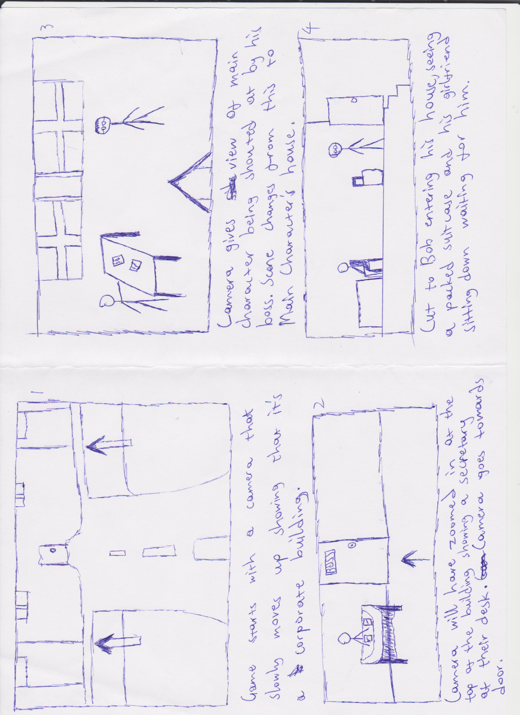

* + - 1. **Cut scene #2**
         1. **Actors**

The characters involved here are Bob and his girlfriend.

* + - * 1. **Description**

This scene is where we meet Bob’s girlfriend who’s dumping him. It’s also where the game begins and you can start controlling the main character.

* + - * 1. **Script**

**Girlfriend:** We need to talk.

**Bob:** (Confused)

**Girlfriend:** This just isn’t working out. We’ve been growing apart for the last few months and to be honest, I just don’t love you anymore.

**Bob**: . . .

**Girlfriend:** God you’re such a wimp. I can’t even remember why even agreed to go out with you anyways, this was a mistake. Meeting you was just such a huge mistake.

**Bob**: . . .

**Girlfriend:** I’ve packed your stuff already, so you can just go.

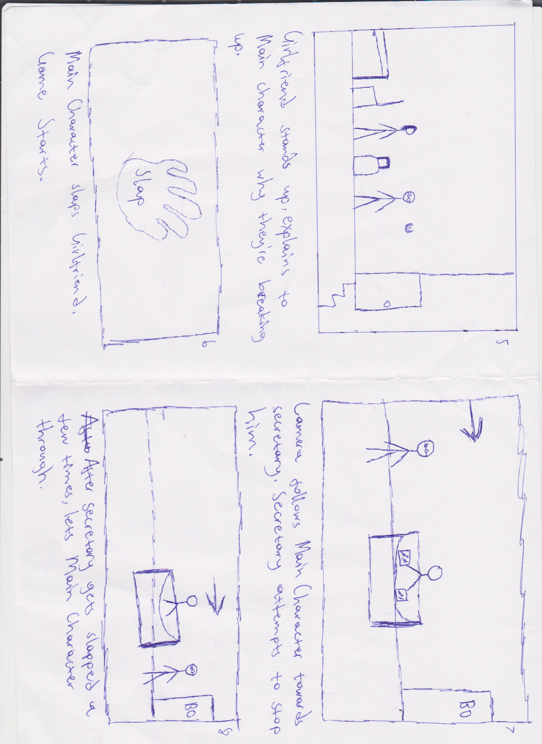

**Bob**: . . .

**Girlfriend:** What are you waiting for? GO!

**(Slap)**

* + - 1. **Cut scene #3**
         1. **Actors**

Bob and a large group of university students are involved here.

* + - * 1. **Description**

After a lot of climbing and slapping, Bob finally manages to get to his Boss’ room and confront him once and for all.

* + - * 1. **Script**

**Boss:** Who are you? How did you get in here?

**Bob**: . . .

**Boss:** Oh wait….I remember you.

**Bob**: . . .

**Boss:** I don’t know what you’re doing here but if you’re responsible for all the complaints down stairs.

(Bob slaps Boss)

**Boss:** WHAT! YOU WILL PAY FOR THAT!!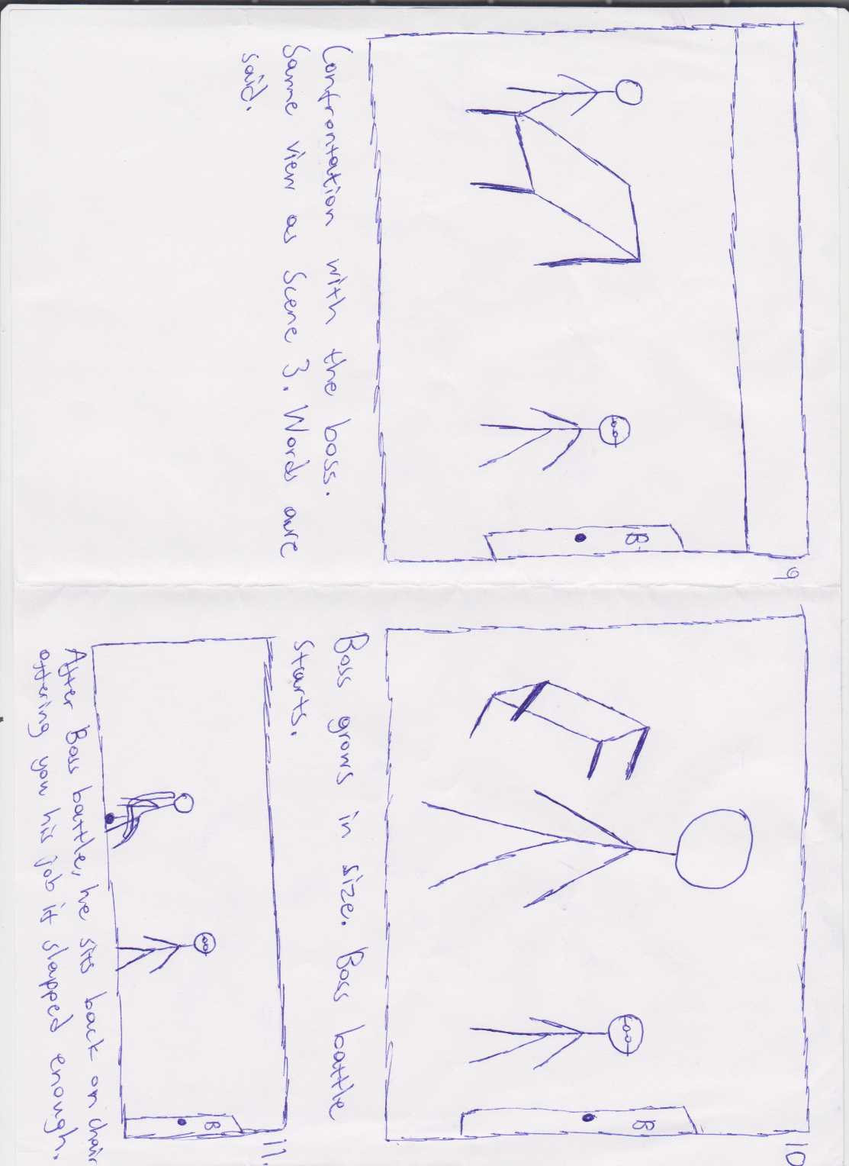

* 1. **Game World – The City**
     1. **General look and feel of world**

The City is a normal one. A lot of the buildings are very modern and a few sky scrapers here and there. The areas of interest involved in this world are the neighborhood, the city street leading to work, the parking lot, your former work place and finally, the university.

* + 1. **Area #1: The Neighborhood & City Street & Parking Lot**
       1. **General Description**

This area has one notable building, your house. This is where you start the game. Bob’s girlfriend is laying on the floor and although Bob himself can’t see him, we can see there is a man upstairs on top of the bed confirming what both you (the player) and Bob thought his girlfriend was dumping him for.

* + - 1. **Physical Characteristics**

At the beginning, there are a few buildings and a few people walking by (easing you into the game) however as you progress further forward into the city, you start seeing more people, more buildings, less nature. You will also notice on your way to the parking lot, a local pharmacy and a road that leads to a university into the distance (which you can’t go to yet) and at the end you will be at the car park where, there are a few former colleagues, a security guard who checks for I.D. and a revolving door that leads into the reception.

* + - 1. **Levels that use area**

Levels 1 and 2 will take place in this area, Level 1 will deal with the basics of the game whereas level 2 will be more challenging.

* + - 1. **Connections to other areas**

This area leads to the workplace where the final level is as well as the university were the game concludes (for now).

* + 1. **Area #2: The Workplace**
       1. **General Description**

This is the final area you will be able to play in. The hardest enemies will be in this area as well as the final Boss you have to fight in order to finish the game. All your knowledge and skills you gained from the previous levels will be tested here to its fullest.

* + - 1. **Physical Characteristics**

You start off at the reception. You will notice that there is an elevator that could take you to the highest floor however you can’t access (or rather, you don’t want to). Instead you make your way to the staircase and go through each floor slapping people. The workplace is generally a gloomy place. There is a lot of gray, office computers and work desks, printers and other office supplies laying around each floor. There will be small room where the secretary is who tells Bob he can’t go through before getting slapped. The Boss’ room has a desk with office supplies which get tossed aside for the boss fight.

* + - 1. **Levels that use area**

Levels 3 and 4 will take place here (Level 3 being the floors leading up to the boss battle and Level 4 being the boss fight itself.

* + - 1. **Connections to other areas**

This area is connected to the Parking Lot which you will go through one last time before finishing the game.

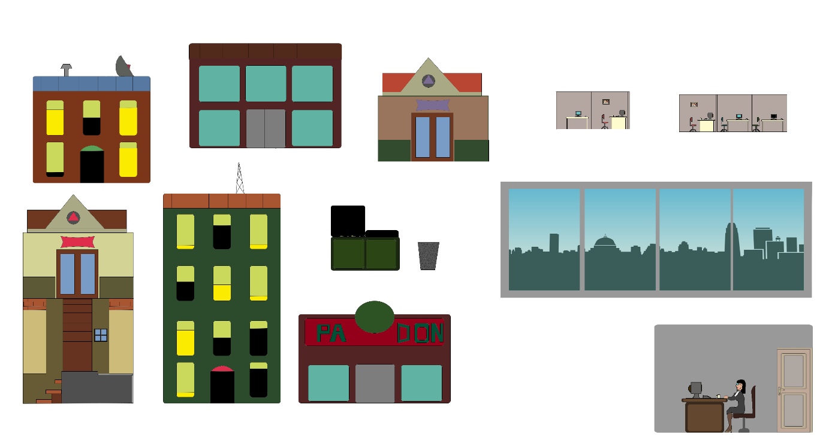

* 1. **Characters**
     1. **Bob**
        1. **Back story**

Bob is your typical salary man. He grew up in a nuclear family household, no brothers, no pets, just him and his parents. He went to primary and secondary with no major incident happening in his life. He also managed to go to university with no complications and also got a job near said university. Shortly after graduating he met his girlfriend and through either extreme luck or pity (no one really knows), he manages to get her to go out with him. He also manages to get a down payment on a house in the suburbs and is steadily paying his mortgage. His girlfriend does not pay any of the bills.

* + - 1. **Personality**

Bob is a typical introvert beta-male. He was told he had a whiny voice by his parents when he was younger and generally stays quiet because of it. He’s incredibly shy and has managed to avoid getting into any incidents throughout his life. His general approach of doing what he’s told and avoiding people has led to him becoming a nobody.

* + - 1. **Look**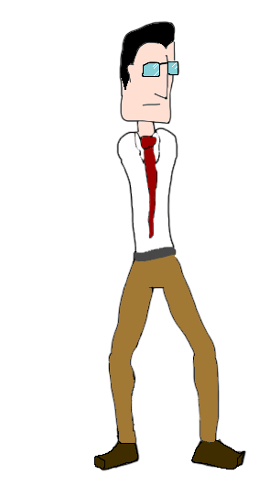
         1. **Physical characteristics**

Bob wears a white shirt with a black tie, black trousers as well as black shoes. He has short hair and glasses. He has no unique features and is generally un-noticeable unless you’re looking for him. He’s also very skinny.

* + - * 1. **Animations**

Bob starts as a normal looking man however over time during the game he becomes stronger physically. Gradually, this body change affects the way he walks as well as how he slaps people (although slapping is mostly affected by power ups)

* + - 1. **Special Abilities**

*Fish dance - A fish weapon to increase damage

-> Large Fishy dance (level 2 attack)

-> Flying Circus Fish dance (level 3 attack) - shoots fish projectiles.

**Pimp Hand** -Power up that increases points currency in tandem with the combo system

**Dust Devil** (base attack) - sends enemy reeling, the knockback is strong enough to send enemies colliding into other enemies.

->Tornado (level 2 attack)

->hurricane (level 3 attack)

**The Wife Beater** – This will half the amount of damage you do normally however when timed right it can do up to 3x normal damage.

**Summon the THUN-DA!!!** – A slap so hard lightning comes down to hit its enemy and applies a Stun to nearby enemies.

**Budhi-smacker -** reduces the amount of health loss per-second.

**Ensmitenment-** + a speed boost to attacks.

**Slap-gri-la -** once activated there is no health loss persecond for the duration of the power up.

**All-mighty-smiter -** complete invincibility for the duration of the power-up.

**The End of it All** – A slap that ends everything by creating a black hole.

**1000 hand slap –** Slap 1000 times. Quickly.

* + - 1. **Relevance to game story**

Bob is the main character, so the entire game and its story revolves around him and his actions.

* + - 1. **Relationship to other characters**

Bob makes no new relationships after slapping his one and only partner and leaving her on the floor, motionless.